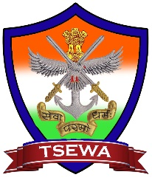
TRI SERVICES EX-SERVICEMEN
WELFARE ASSOCIATION

____________________________________________

Date: - 04th Jan 2020

Donations for the Month of December 2019

The list of donors for the month of Dec 2019 for the maintenance of TSEWA (Tri-Services Ex Servicemen Welfare Association) is as under: -

S.No | Date | M.No | Rank | Name of the Donor | Credit
1 | 01-12-2019 | 2175 | Brig | P.T.Gangadharan | 500.00
2 | 05-12-2019 | 5163 | Lt Col | Jatinder Prakash Malhotra | 1,000.00
3 | 11-12-2019 | 13076 | Nk | Tajender Singh | 1,000.00
4 | 13-12-2019 | NM |  | Smt P Shakuntala Patnaik | 1,00,000.00
5 | 16-12-2019 | Nm |  | Smt Nirmala V Subramanian | 50,000.00
6 | 17-12-2019 | 1380 | Col | K P Seshadri | 10,000.00
7 | 18-12-2019 | NM |  | Smt Mira Devi W/o Late Nb Sub Lallan Singh | 10,000.00
8 | 18-12-2019 | NM | Rect | Nikhil Kumar Rajput | 1,100.00
9 | 21-12-2019 | NM | Sep | Sandeep Joshi | 5,000.00
Total Amount |  |  |  |  | 1,78,600.00

TSEWA is thankful to all the donors

Col Dr G B Sethi
General Secretary,
TSEWA
9440859877

